********

What’s the buzz in March?

We have a very exciting month ahead in March with lots of celebrations coming up! Our new theme is PEOPLE WHO HELP US, so we’re asking any parent who works as a nurse, doctor, driver, chef, bin man, etc. to come in and speak to our classes about their jobs. Please speak with your class teacher if you would be willing to.



**Monthly Theme**

The theme for this month is

PEOPLE WHO HELP US

and our colour of the month is green.

In class we will be looking at the following things:

* Spring colours; Green, yellow, orange, pink,

purple.

* Exploring the jobs of all the people who help us.
* Role playing being doctors, nurses and dentists.
* Making craft items for Spring, St. Patrick’s Day and, of course, Mother’s Day.
* Circle time activities discussing people who help us in the community, things we do with our Mammies, why they are important to us, what changes we see in Spring.

***Here are some ideas about how you can help reinforce these topics at home:***

* Take your child on a Spring walk – point out the new growth on trees, spring flowers, baby lambs and bird activity.
* Keep reading to your child and helping them read their own name.

The



**MUFFINS FOR MUM**

To celebrate Mother’s Day, we are inviting all our mammies and significant females into the assembly hall on Thursday 7th March from 9.15am – 10.15am. As it is World Book Day, children can wear their pyjamas to school and bring in their favourite book. We will enjoy reading stories together with some lovely treats.

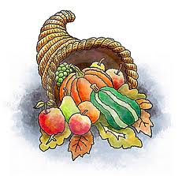



**Family Project**

Spring is finally here! This month we would like to celebrate spring by making spring flowers with our families. Children can bring in a spring flower or spend time decorating one with their family at home. We would like all flowers in by Wednesday 27th March.

**Saint Patrick’s Day**

We are looking forward to starting some St Patrick’s Day celebrations in school this month. The children will finish on Friday 15th March at 12.00pm. The school will reopen on Tuesday 19th March.





**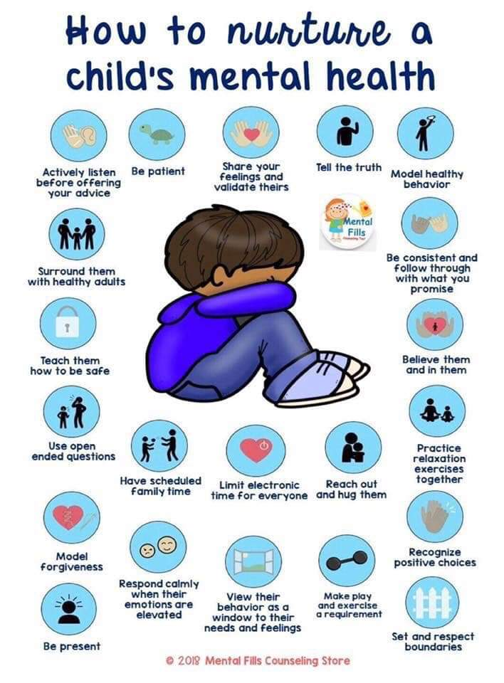******

**Important Dates for your diary**

***7th March –*** *Muffins with Mum and World Book Day*

***13th – 15th March-*** Parent Teacher meetings

***15th March –*** *Children finish at 12.00pm*

***18th March*** *– School closed*

***22nd March*** – Trip to Playshed

**28th March** – Children finish at 12.00pm

***29th March – 8th April*** – Easter holidays

***17th April*** – School reopens

**Parent Teacher Meetings**

From Wednesday 13th March, we will be holding our second parent teacher meetings of the year. The children will finish school at 12.00pm on Friday 15th March to cater for these meetings. Please make sure you have selected a time slot on the sign-up sheet on the Nursery notice board.

**School Trip**

We are hoping to have our next school trip on Friday 22nd March. The children will be going to the Play Shed. Children must wear their uniform on this day. The cost of the trip will be £5.00 as the remainder will be paid for using snack money. You will receive a permission slip closer to the time.

**Nursery Birthdays**

Happy birthday to all these children who have birthdays during the month of March.

***4th – Thea Kelly***

***16th – Emily Canning***

***23rd – Lúna Morrow***