********

What’s the Buzz in February?

It’s **finally** February! We had lots of fun learning all about the winter season last month and we had the best day in school with our grandparents.

Love is very much in the air this month in our nursery! We will be having a **Happy Heart Day** this month, which you can read more about below.

**Monthly Theme**

The theme for this month is: Love and Feelings and the colours **red** and **pink**.

In class we will be looking at the following things:

* The colours red and white and mixing these together to make pink
* Creating different sized hearts for collage / 3D art work
* Making craft items related to theme of feelings
* Circle time activities discussing our feelings e.g. what makes us feel happy/sad/ scared/angry etc.

Ideas to try at home with your child:

* Discuss the topic of feelings with your child. Encourage children to discuss their own feelings, encourage them to say why something makes them feel a particular way. Adults can model this. Inside Out is a great film to support this
* Make valentines cookies, using heart cutters and discuss the process of what happens, e.g. first/then/later .
* Finding shapes in the environment, hearts in shop windows, circle signs, square windows, rectangle doors etc.
* Encourage children’s awareness around letters in their name. This can be done by drawing their attention to letters in the environment labels or symbols / stories / rhymes, emphasising sounds.

The



**Family Project**

This month’s family project is linked to our theme of “love” and “feelings”. We are asking families to design and decorate a heart. This can include anything from scrap materials, to family images or drawings of the things and people you love. The snowmen / babies / boys and girls were absolutely fantastic and the children were so proud of their work. Thank you for your input to this project, we can’t wait to see what your February project brings.

Please bring completed hearts in by Monday 26th February.



****[](http://www.google.co.uk/imgres?imgurl=http://www.sxc.hu/pic/m/j/ja/jaylopez/1130153_how_to_cut_a_perfect_valentines_heart_.jpg&imgrefurl=http://www.sxc.hu/photo/1130153&usg=__UgbbqupYdqdJouzJ6Ffbg4TpW3k=&h=300&w=299&sz=8&hl=en&start=41&zoom=1&tbnid=_NVUkncbylMUDM:&tbnh=116&tbnw=116&ei=fOEHUYqMGcqWhQehxIHYAg&prev=/search?q=heart+valentines+images&start=40&hl=en&safe=active&sa=N&gbv=2&tbm=isch&prmd=ivns&itbs=1)

**Learning Packs**

We are so delighted to see the learning packs and games being enjoyed at home. The children have loved showing you their learning.

We would ask that all learning packs are repacked carefully to make sure all the pieces are included. If anything goes missing from your pack, please let your class teacher know to avoid children getting packs with missing pieces the following week.

**[](http://www.google.co.uk/imgres?imgurl=http://a.dryicons.com/files/graphics_previews/valentine_heart.jpg&imgrefurl=http://dryicons.com/free-graphics/preview/valentine-heart/&usg=__5qA6IWRqAX0xcUIe8YuftaTn_Zc=&h=280&w=512&sz=50&hl=en&start=27&zoom=1&tbnid=IjGuc97hor_xHM:&tbnh=72&tbnw=131&ei=P-EHUfTuI4eLhQepwoB4&prev=/search?q=heart+valentines+images&start=20&hl=en&safe=active&sa=N&gbv=2&tbm=isch&prmd=ivns&itbs=1)**

**School Closure**

The children have a week-long holiday in February for half term. **The school therefore will be closed from Monday 12th and re-open on Monday 19th February.**

****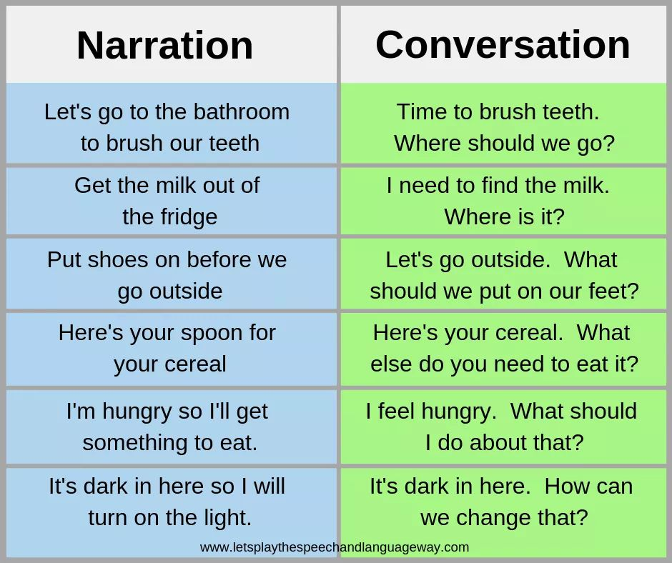**MC900437561[1]****[](http://www.google.co.uk/imgres?imgurl=http://a.dryicons.com/files/graphics_previews/valentine_heart.jpg&imgrefurl=http://dryicons.com/free-graphics/preview/valentine-heart/&usg=__5qA6IWRqAX0xcUIe8YuftaTn_Zc=&h=280&w=512&sz=50&hl=en&start=27&zoom=1&tbnid=IjGuc97hor_xHM:&tbnh=72&tbnw=131&ei=P-EHUfTuI4eLhQepwoB4&prev=/search?q=heart+valentines+images&start=20&hl=en&safe=active&sa=N&gbv=2&tbm=isch&prmd=ivns&itbs=1)** 

**Happy Heart Day**

On Friday 9th February, we are having a ‘Happy Heart Day’

We are hoping to raise awareness among the children about how to keep our hearts healthy.

The children are invited to wear red and pink

for the day and we have a range of

fun activities lined up. **Children will finish**

**school at 12.00pm on this day.**

**Important Dates for your diary**

**2nd Feb –** Trip to Omniplex cinema

**9th *Feb –*** Happy Heart Day

***12th-16th Feb* –** School closed for mid term break.

**Promoting Language Development**

Below are some ideas about how to promote language development naturally during your child’s daily routine. In Nursery we are aiming to increase conversation opportunities by asking *open ended* questions.

**Promoting Language Development**

Below are some ideas about how to promote language development naturally during your child’s daily routine. In Nursery we are aiming to increase conversation opportunities by asking *open ended* questions.

**Snack Money and Spare Clothes**

This is a polite reminder for parents to pay snack £3.00 money every Monday morning for the week ahead.

We would also ask that all parents make sure that their child has spares clothes, especially underwear and trousers.

**Nursery Birthdays**

Happy Birthday to all these children who have birthdays during the month of February.

***5th- Lexi Mullan***

***5th – Koah Moore***

***6th- Vaeda Berwick***

***7th- Jackson Smallwoods***

***9th – Evie Mc Laughlin Bradley***

***12th- Kyra Logue***